|  |  |  |  |  |
| --- | --- | --- | --- | --- |
| **Multicultural Arabic Story time Program**  برنامج وقت القصة العربية متعدد الثقافات |  |  |  |  |
| Topics | Story and Book | Activity | Resources |  |
| Introduction to Health and safety  مقدمة في الصحة والسلامة | Welcome Song Introducing each other  “ Head shoulders Knees and toes”  Childrens favourite Ryhmes | Introduction to Health and safety  Activity | Printout, Texters, Crayons,Scissors,Glue stick, Stickers, Glitter. |  |
| Handwash Hygiene  غسل اليدين النظافة | Welcome Song Introducing each other  “This is the way we wash our hands”  Childrens favourite Ryhmes | Handwash Hygiene  Activity | Printout, Texters, Crayons,Scissors,Glue stick, Stickers, coloured paper, Glitter |  |
| Oral Hygiene  نظافة الفم | Welcome Song Introducing each other  “If you are happy and you know it clap your hands”  Childrens Favourite Rhymes | Oral Hygiene  Activity | Printout, Texters, Crayons,Scissors,Glue stick, Stickers, Glitter |  |
| Having a bath  الاستحمام | Welcome Song Introducing each other  “Hokey Pokey”  Childrens Favourite Rhymes | Having a bath  Activity | Printout, Texters, Crayons,Scissors,Glue stick, Stickers, Glitter |  |
| Coughing and sneezing  السعال والعطس | Welcome Song Introducing each other  “Zoom Zoom Zoom we are going to the moon”  Childrens Favourite Ryhmes | Coughing and sneezing  Activity | Printout, Texters, Crayons,Scissors,Glue stick, Stickers, Glitter |  |
| After using the Toilet  بعد استخدام المرحاض | Welcome Song Introducing each other  ‘Five little Monkeys”  Childrens Favourite Rhymes | After using the Toilet  Actiovity | Printout, Texters, Crayons,Scissors,Glue stick, Stickers, Glitter |  |
| Before we Eat  قبل أن نأكل | Welcome Song Introducing each other  “ Incy Wincy Spider”  Childrens Favourite Rhymes | Before we Eat Activity | Printout, Texters, Crayons,Scissors,Glue stick, Stickers, Glitter |  |
| Self Check hygiene needs  التحقق الذاتي من احتياجات النظافة | Welcome Song Introducing each other  “Open Shut them”  Childrens Favourite Rhymes | Self Check hygiene needs Activity | Printout, Texters, Crayons,Scissors,Glue stick, Stickers, Glitter |  |
|  |  |  |  |  |
|  |  |  |  |  |
|  |  |  |  |  |

**طابق كل صورة نظافة مع منتجات النظافة لاستخدامها في العناية بهذا الجزء من جسمك**

**النظافة الصحية ماذا نحتاج؟**

**ارسم خطا إلى المكان الذي تستخدم فيه هذا المنتج على الجسم**

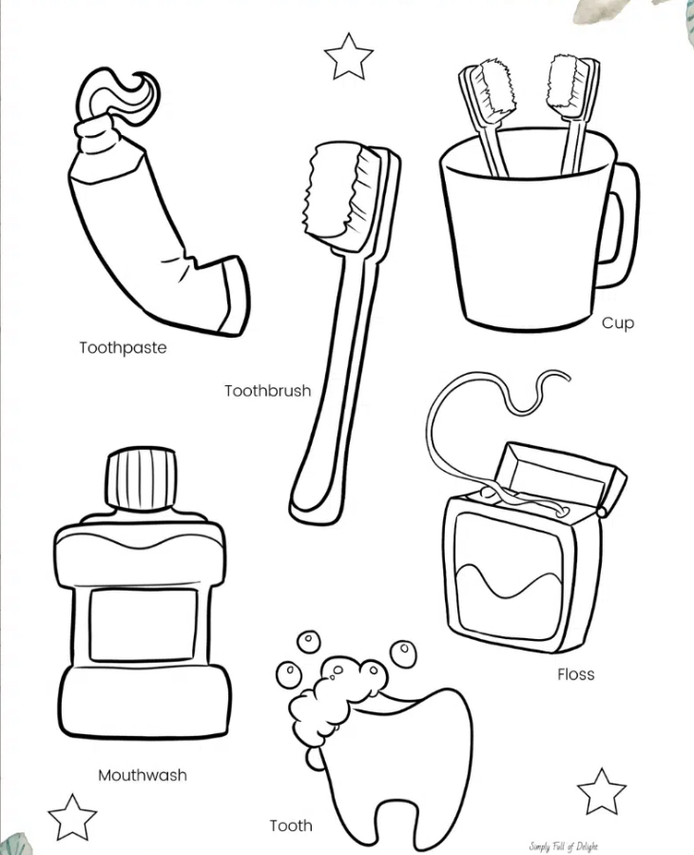**النظافة الجيدة** **ماذا نحتاج؟ ارسم خطا إلى المكان الذي تستخدم فيه هذا المنتج على الجسم**

**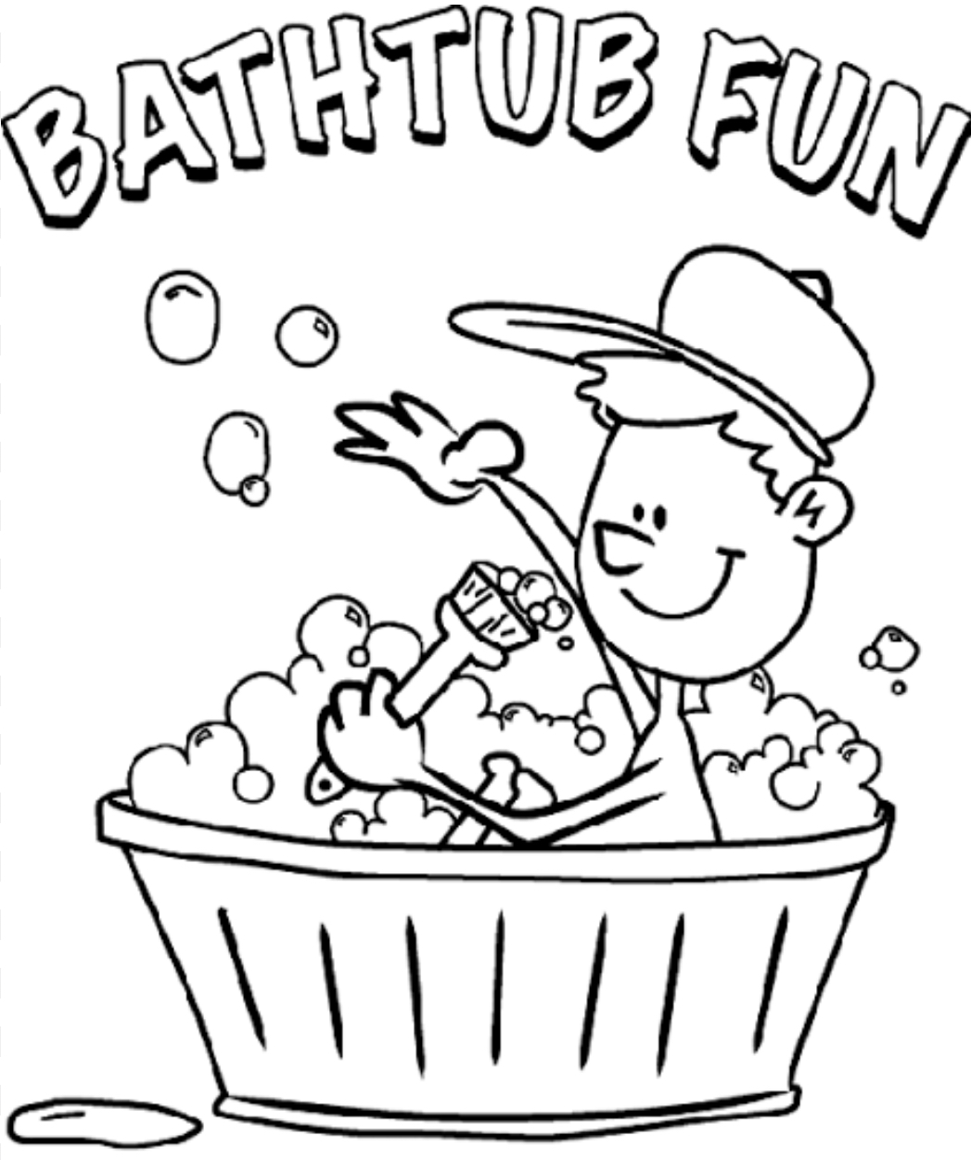  
حوض الاستحمام المرح**

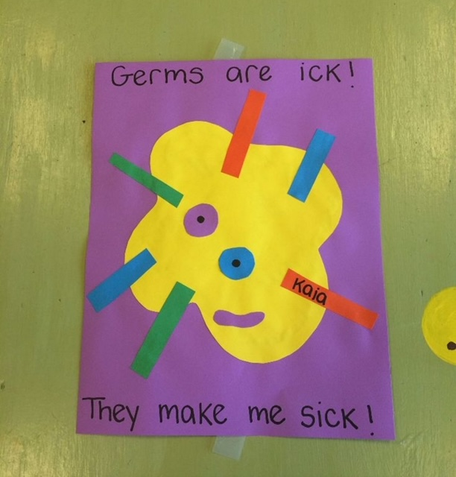

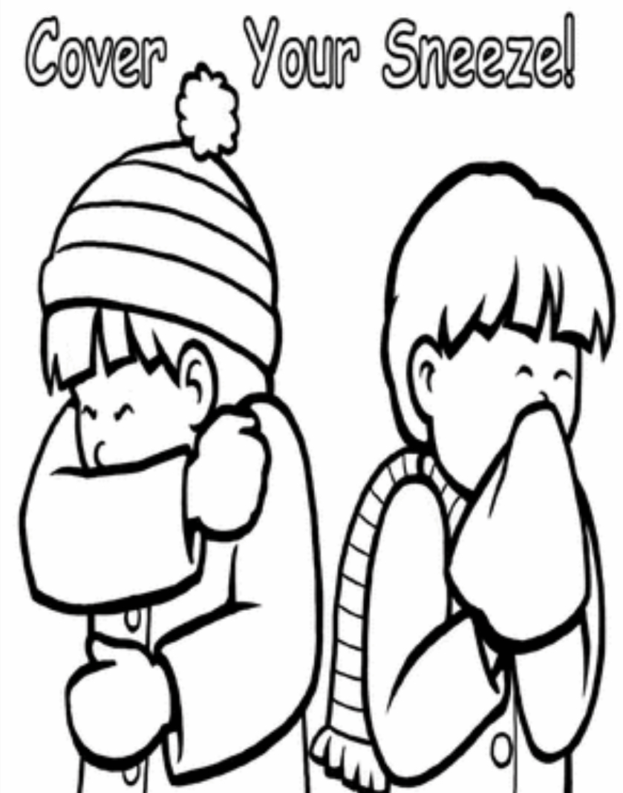

**غط عطسك**

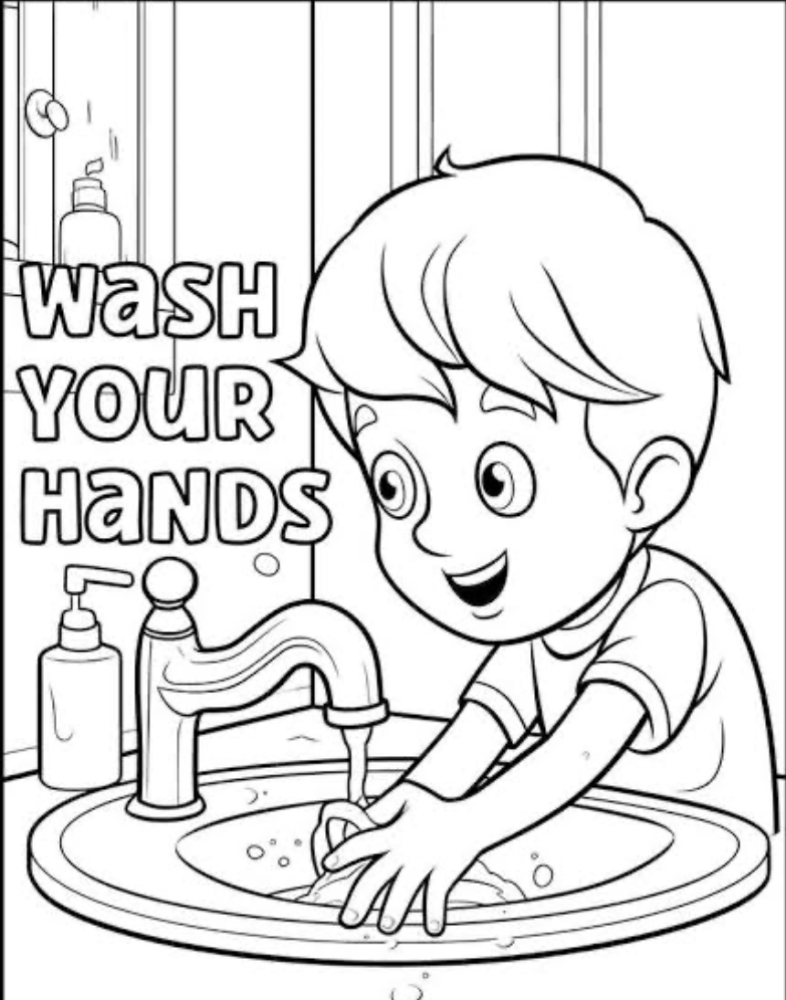

**غسل يديك**

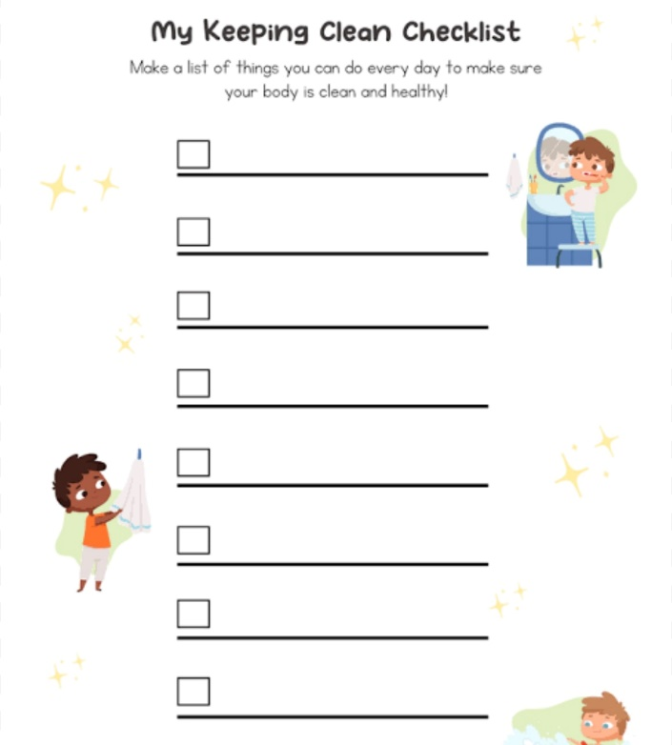

**قائمة التحقق من الحفاظ على النظافة الخاصة بي**